**Project 4: Reading From an Excel File**

**Problem Statement:**

To read an excel file using a Bot and display each column has message box.

**Solution Definition:**

1. Create an Excel File with Records in it.
2. Open the Excel File through its path (Action: ‘Excel: Open’).
3. Retrieve All the records and store it in Table Variable (Action: ‘advanced: Get Multiple Cells’).
4. Retrieve records from it using Loop (Action: ‘Loop’) (The value is Stored in Record Variable).
5. Retrieve Each Row Value from Record Variable and display it using Message Box.
6. Close the Excel Sheet.

**Procedure to Create the Bot:**

1. Login to your Control Room.

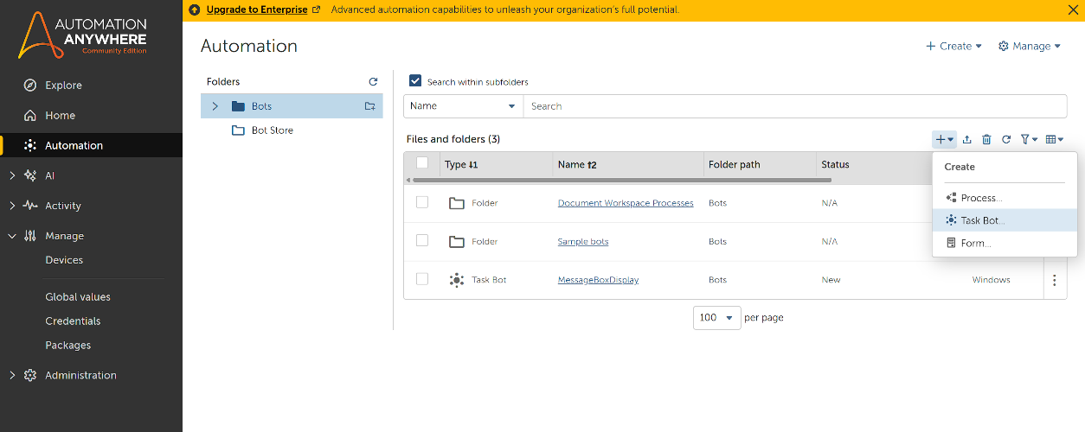

1. Click Automation in the Left Rail and click Create New Task Bot as Shown Above.
2. Enter the name of the bot and leave other options.
3. You will be re-directed to Action Panel of the Bot.

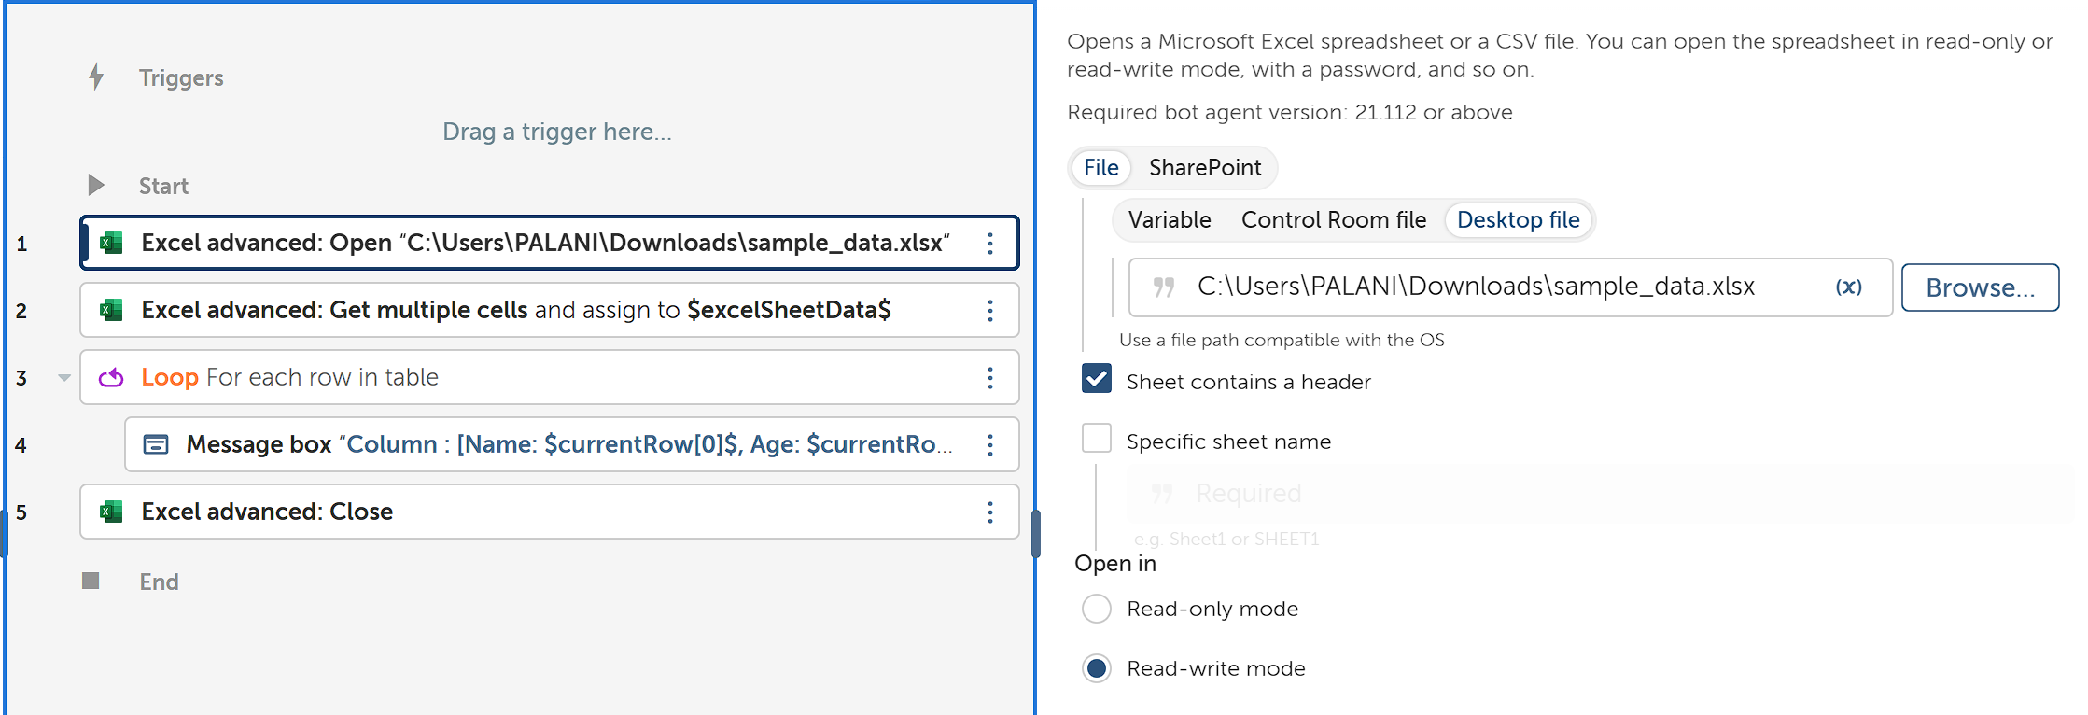

1. Open the Excel File Using Excel: Open and provide the path to that Excel file.

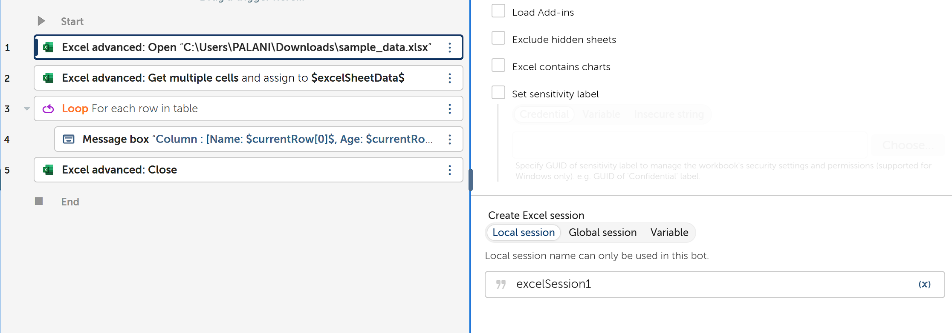

1. Add Session name for future references which will be Available at the Bottom of Action Details of Excel: Open.

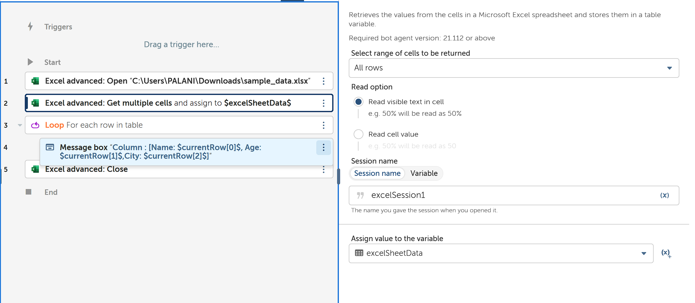

1. To retrieve the table available in the Excel File, Use Excel advanced: Get Multiple Cells and store it in Table Variable.

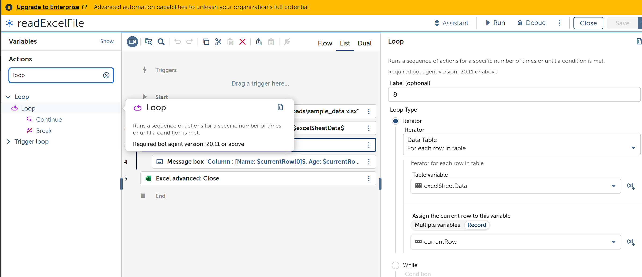

1. Now Use Loop to Extract Each Column and store it in Record Variable

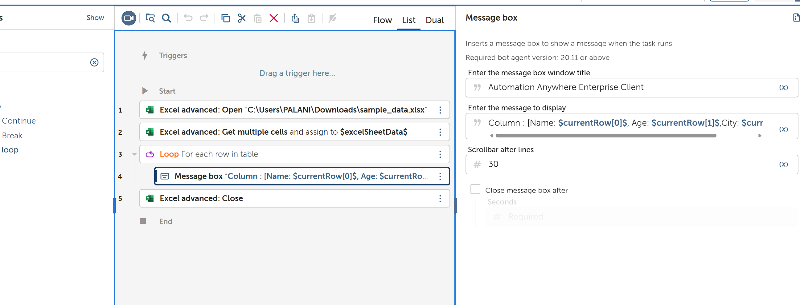

1. We will Display the retrieved Record Using Message Box. Note How the Row values form each column are addressed.

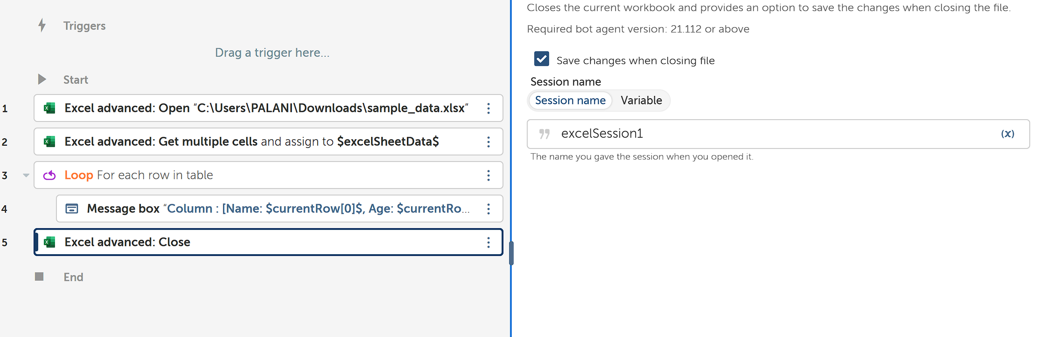

1. Outside the loop, Close the Excel File opened using its Session instance.

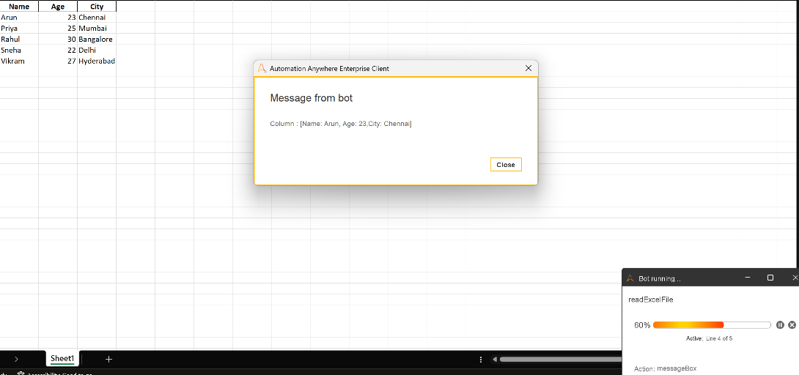

1. This is How output of a Single Record Instance looks like.
2. Bot has Run Successfully.